**PFP – Assignment 02**

**Q1 (5 marks). Use list**

Develop the program that helps user managing an integer numbers(maximum of 100 elements) , using the following simple menu:

1- User enter the list of integer number . The input will terminate if user enters the value 0

2- Search for a value in a list entered by the user.

3- Print out the element with the largest value in the list

4- Remove the element whose value is equal to the value entered by the user

5- Print out the list in ascending order

6- Others- Quit

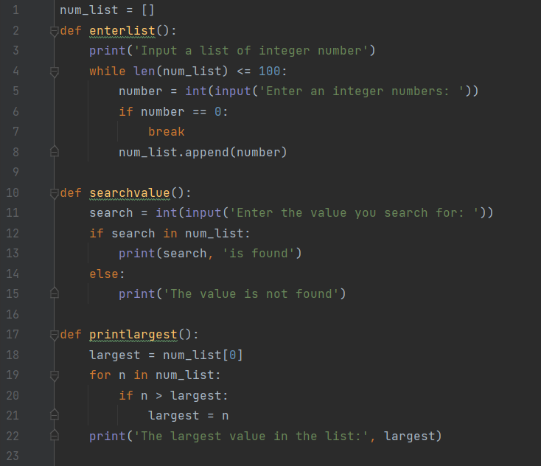

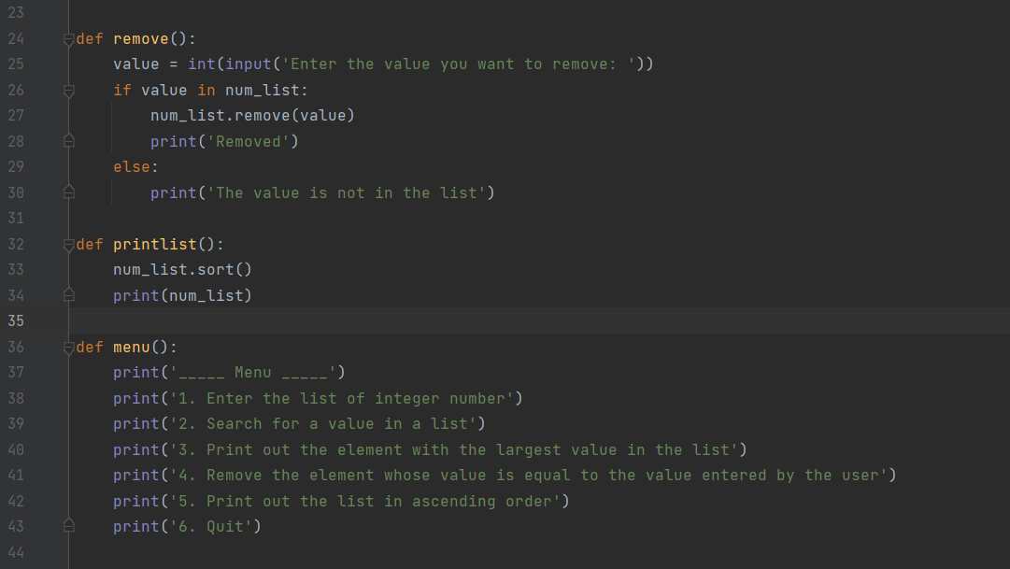

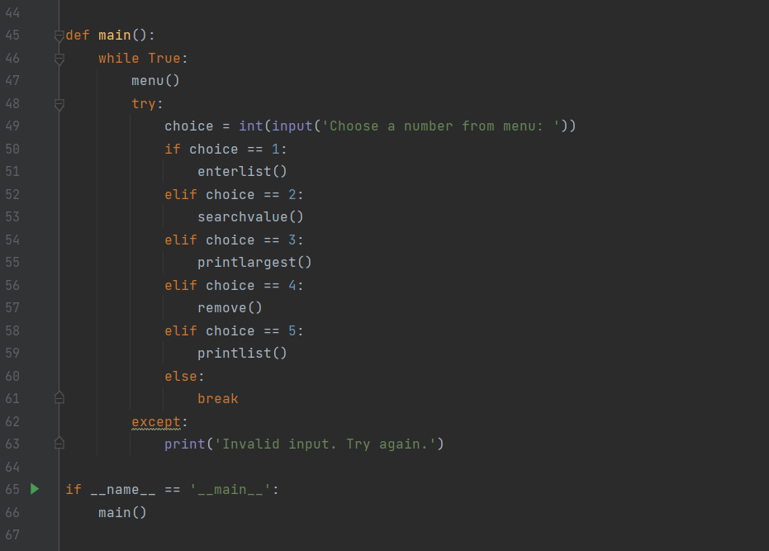

**Q2 (5 marks). Use list**

Write the program that helps user managing a list of 100 student first names using the following menu:

1-Enter the number of students in the class (10< number of students <=100).

2- Add a student list

3- Remove students with the same first name

4- Print out students whose first name contains the string "an"

5- Print the list in descending order

6- Quit

